Linear regression:
Linear regression is a statistical technique used to find the relationship between variables. In an ML context, linear regression finds the relationship between features and a label.
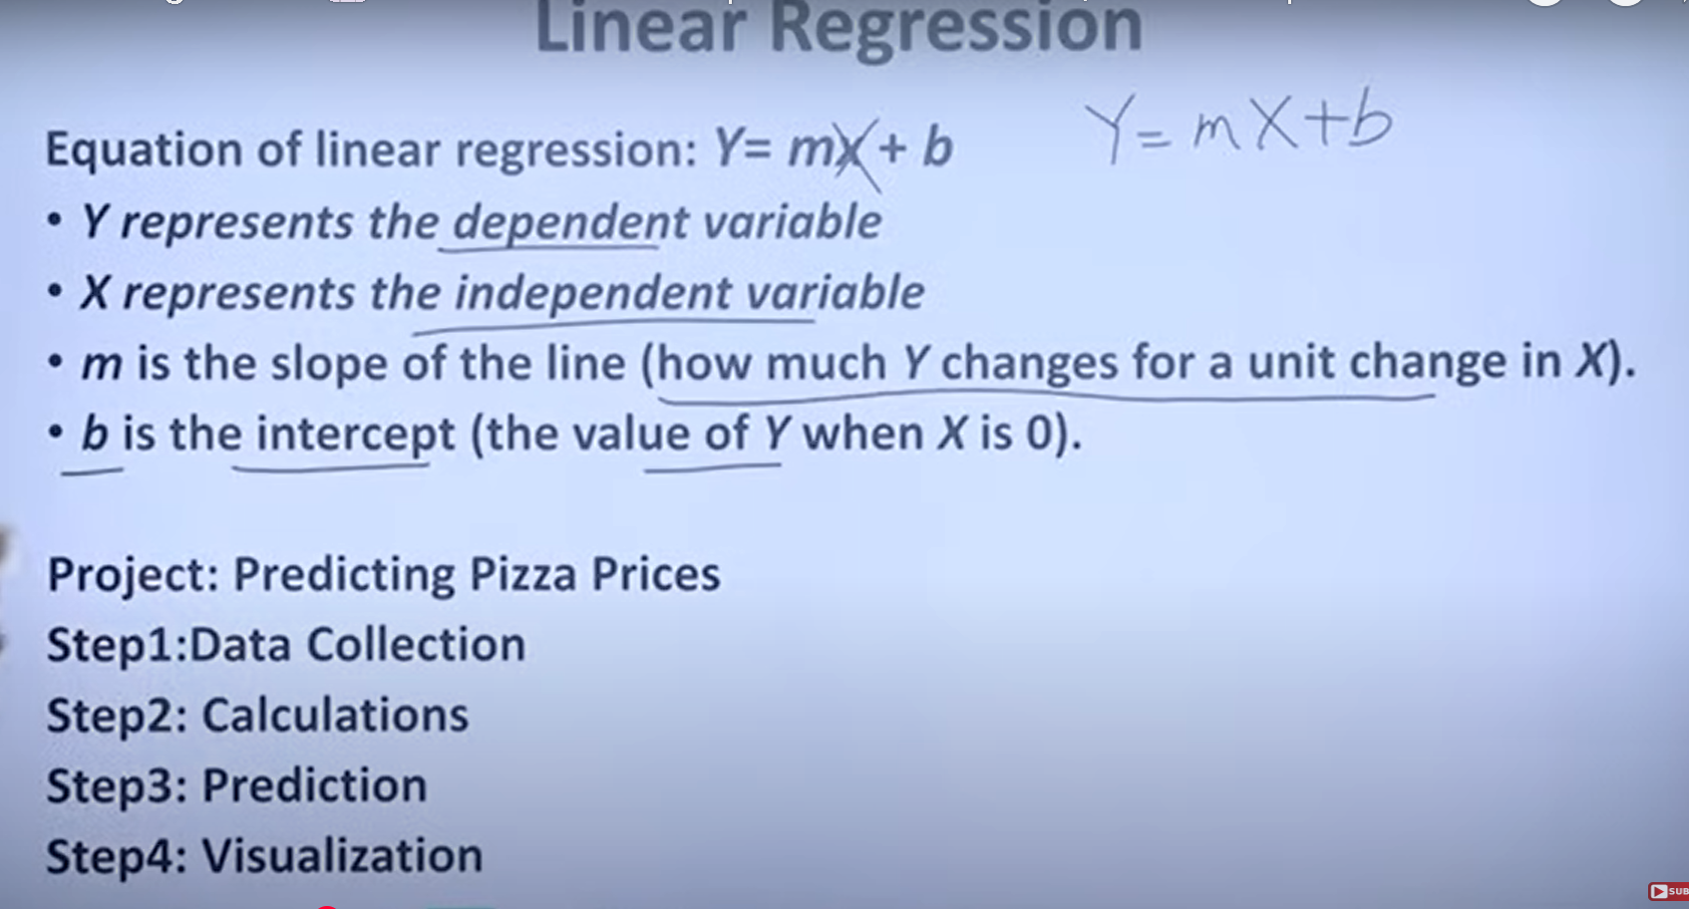
To predict the price of pizza by using independent variable diameter of the pizza
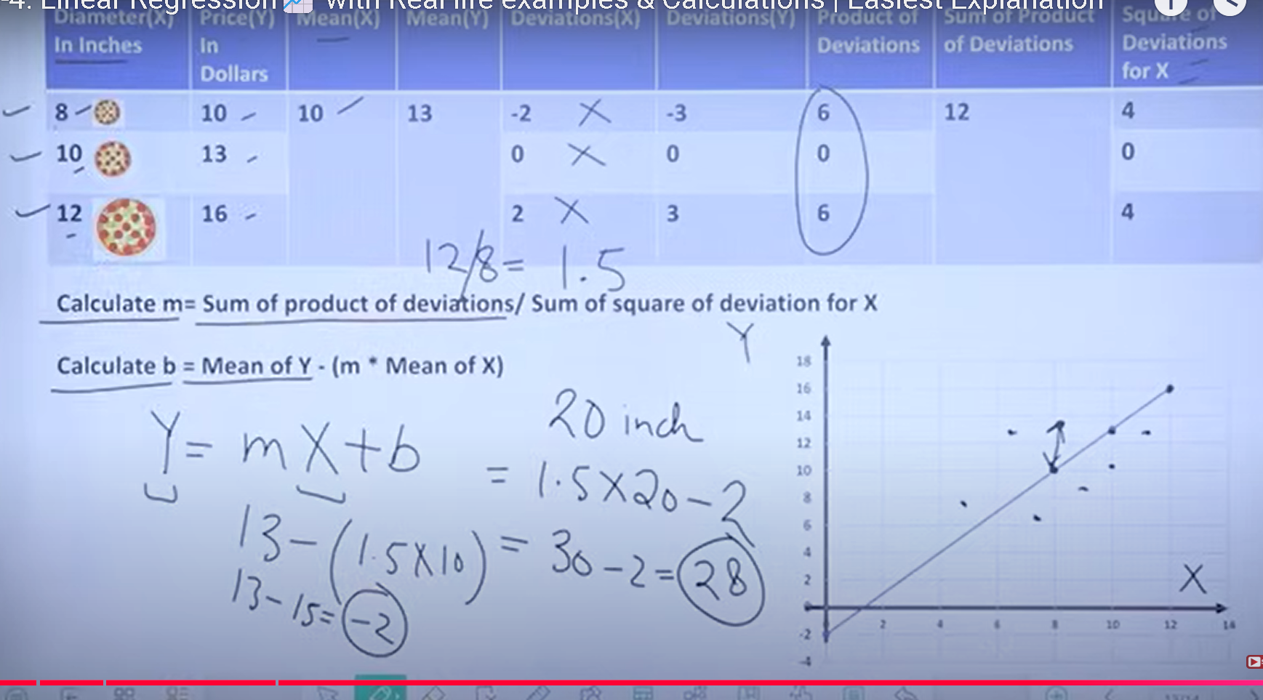
Q: What is updated in linear regression?
Ans: bias and weight which is b and x
Linear regression: Loss :
Loss is a numerical metric that describes how wrong a model's predictions are. Loss measures the distance between the model's predictions and the actual labels. The goal of training a model is to minimize the loss, reducing it to its lowest possible value
In the following image, you can visualize loss as arrows drawn from the data points to the model. The arrows show how far the model's predictions are from the actual values
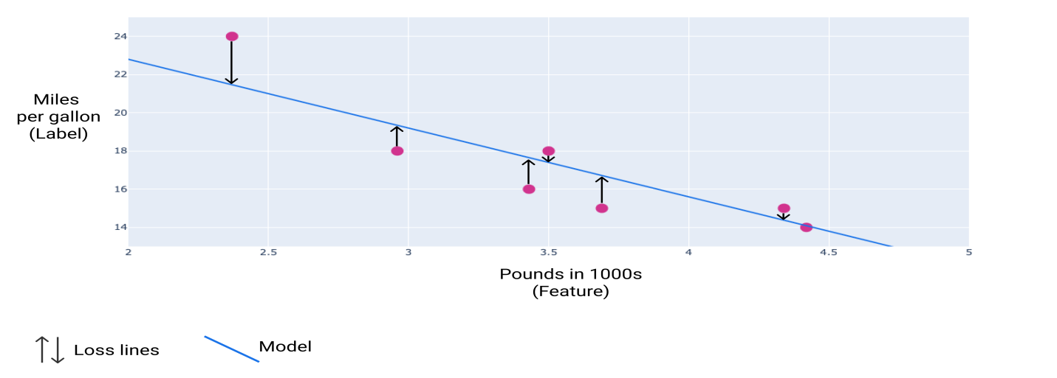
Distance of loss:
Distance btw the predicted value and the actual value ex. Predicted value is 2 but actual value is 5 then the distance of loss is 3.
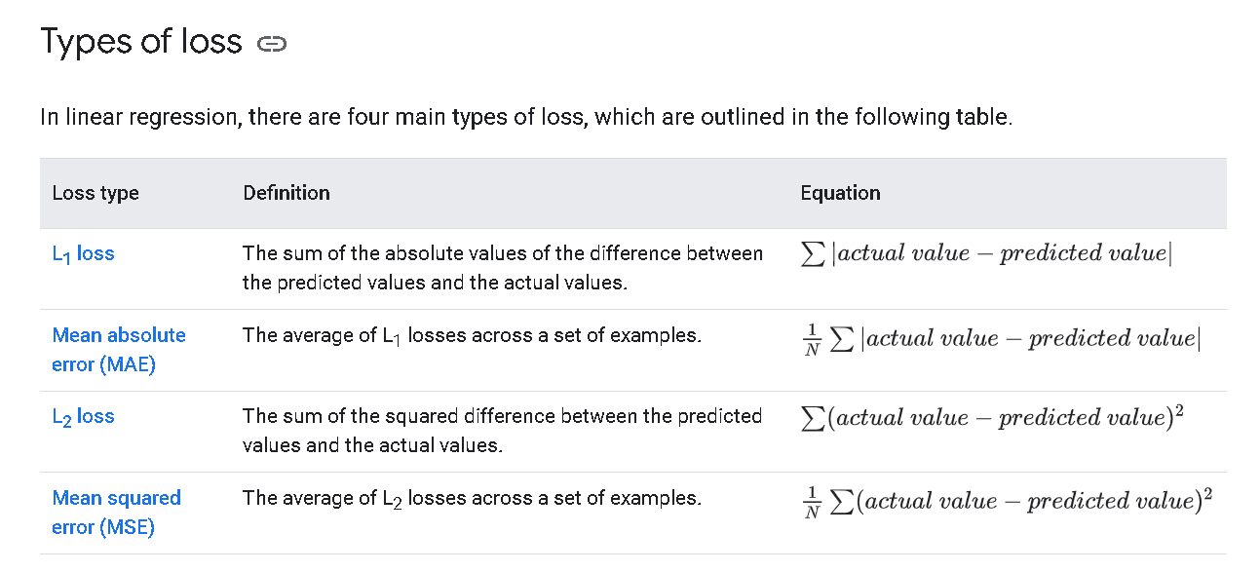
Outlier:
An outlier can also refer to how far off a model's predictions are from the real values.
MSE: decrease the outlier (distance)
MAE: increase the outlier (distance)
Gradient descent is a mathematical technique that iteratively finds the weights and bias that produce the model with the lowest loss. Gradient descent finds the best weight and bias by repeating the following process for a number of user-defined iterations.
The model begins training with randomized weights and biases near zero, and then repeats the following steps:
- Calculate the loss with the current weight and bias.
- Determine the direction to move the weights and bias that reduce loss.
- Move the weight and bias values a small amount in the direction that reduces loss.
- Return to step one and repeat the process until the model can't reduce the loss any further.
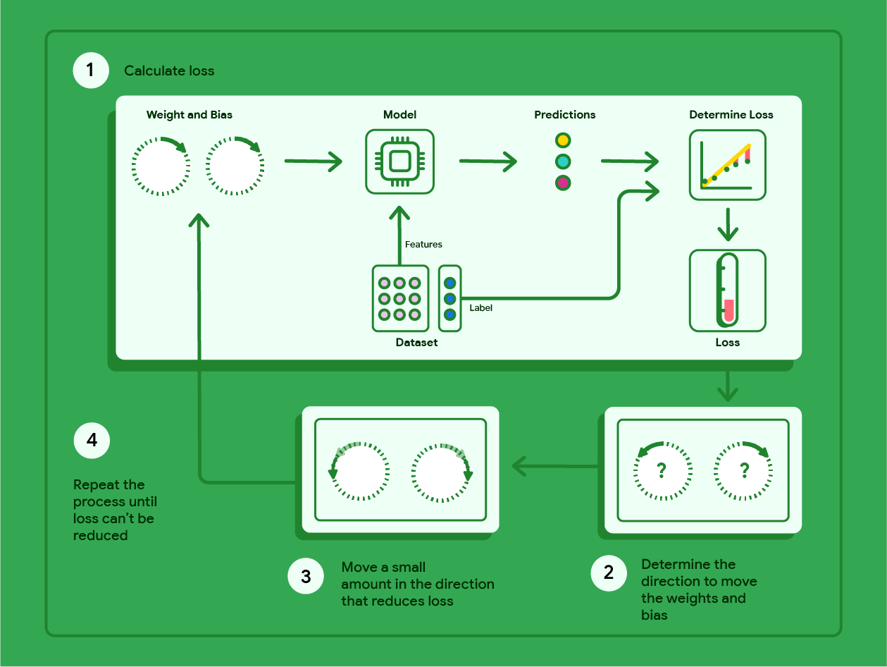
Figure 12. Gradient descent is an iterative process that finds the weights and bias that produce the model with the lowest loss.
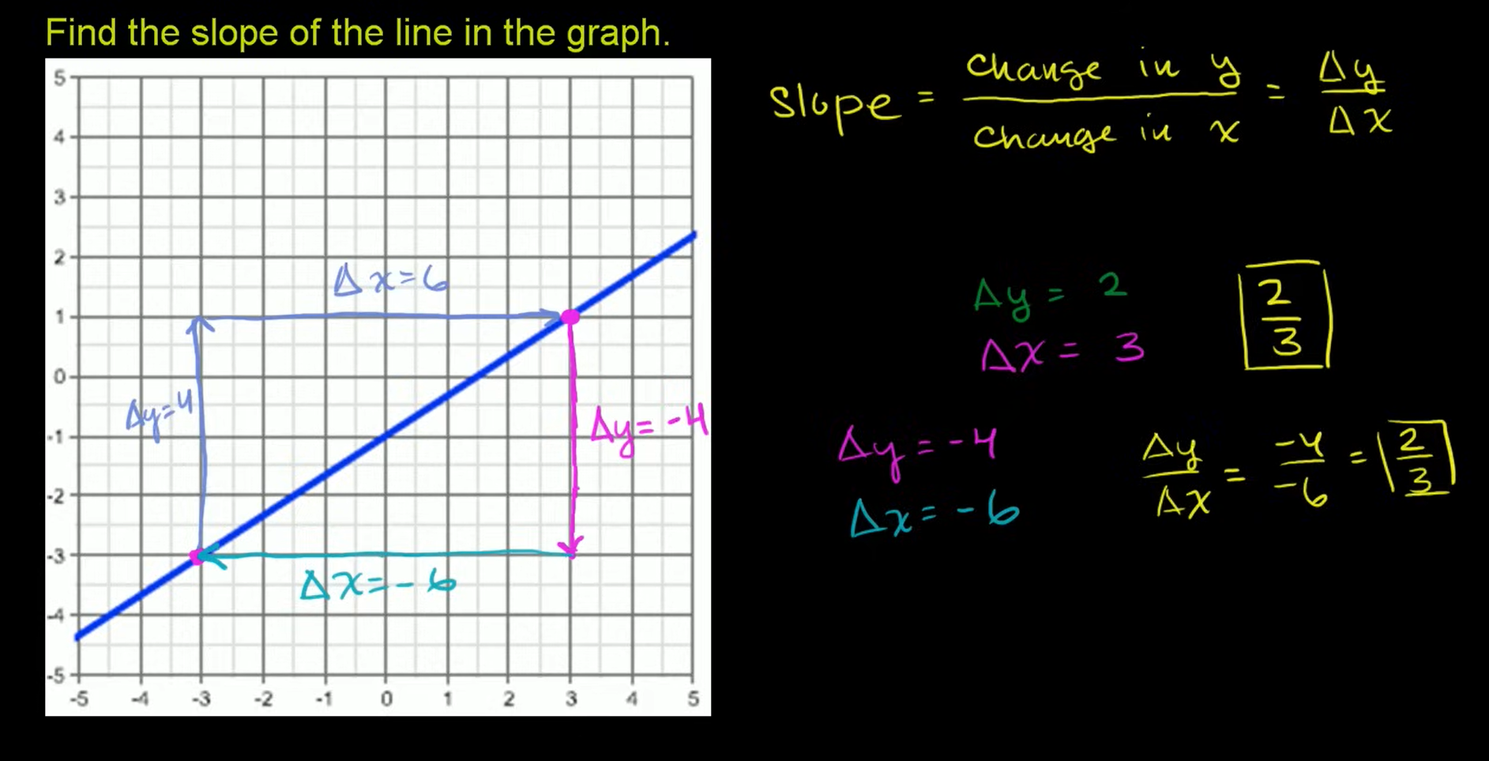
Q: What's the role of gradient descent in linear regression?
Gradient descent is an iterative process that finds the best weights and bias that minimize the loss.

Convergence and convex functions:

The loss functions for linear models always produce a convex surface.

when a linear regression model converges, we know the model has found the weights and bias that produce the lowest loss

Hyperparameters :
Hyperparameters are variables that control different aspects of training. Three common hyperparameters are:
- Learning rate
- Batch size
- Epochs

Learning rate:
is a floating point number you set that influences how quickly the model converges. If the learning rate is too low, the model can take a long time to converge.

What is the ideal learning rate?
The ideal learning rate is problem-dependent.
Each model and dataset will have its own ideal learning rate.

Batch size
Batch size is a hyperparameter that refers to the number of examples the model processes before updating its weights and bias.
Stochastic gradient descent (SGD): Stochastic gradient descent uses only a single example (a batch size of one) per iteration. Given enough iterations, SGD works but is very noisy. "Noise" refers to variations during training that cause the loss to increase rather than decrease during an iteration. The term "stochastic" indicates that the one example comprising each batch is chosen at random

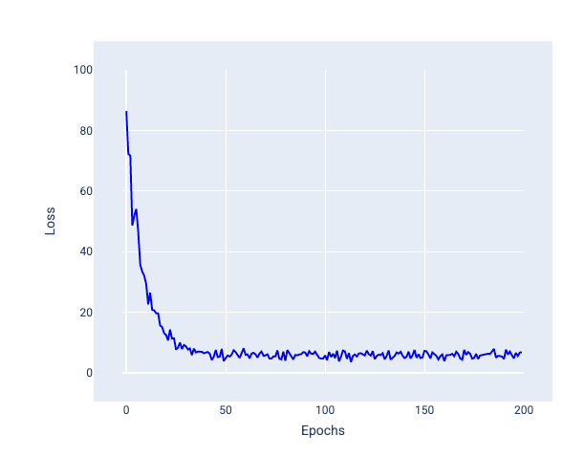
Model trained with stochastic gradient descent (SGD) showing noise in the loss curve.
Note that using stochastic gradient descent can produce noise throughout the entire loss curve, not just near convergence.

Mini-batch stochastic gradient descent (mini-batch SGD): Mini-batch stochastic gradient descent is a compromise between full-batch and SGD. For N number of data points, the batch size can be any number greater than 1 and less than N. The model chooses the examples included in each batch at random, averages their gradients, and then updates the weights and bias once per iteration.
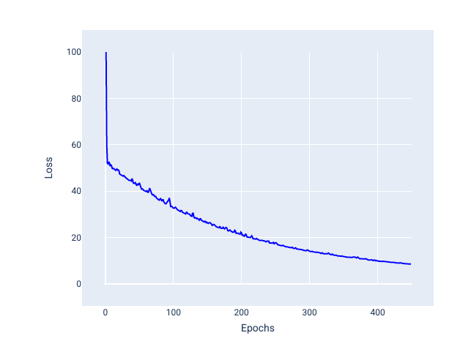

Model trained with mini-batch SGD.

Epochs
During training, an epoch means that the model has processed every example in the training set once. For example, given a training set with 1,000 examples and a mini-batch size of 100 examples, it will take the model 10 iterations to complete one epoch.
